Aim
To perform basic image processing by reading an image using Python and applying Gaussian Blur to reduce noise and smooth the image.

Apparatus / Software Required
- Google Colab
- Python
- OpenCV (cv2)
- Matplotlib
- Input image (.jpg, .png, etc.)

Procedure
- Open Google Colab and create a new notebook.
- Import the required libraries: OpenCV and Matplotlib.
- Upload the required image using files.upload().
- Read the uploaded image using cv2.imread().
- Apply Gaussian Blur using cv2.GaussianBlur().
- Use a 15 × 15 kernel for smoothing the image.
- Display the original image.
- Display the Gaussian-blurred image.
- Compare the original and blurred images.
Code:
# ============================================
# Gaussian Blur on an Image using OpenCV
# ============================================

# Step 1: Import libraries
from google.colab import files
import cv2
import matplotlib.pyplot as plt

# Step 2: Upload the image
uploaded = files.upload()

# Step 3: Get filename
filename = list(uploaded.keys())[0]

# Step 4: Read the image
image = cv2.imread(filename)

if image is None:
print("Error: Unable to read the image.")
else:
print("Image uploaded successfully:", filename)

# Step 5: Apply Gaussian Blur
# (15, 15) = kernel size
# 0 = automatic sigma calculation
blur_image = cv2.GaussianBlur(image, (15, 15), 0)

# Step 6: Display original and blurred images
plt.figure(figsize=(10, 4))

# Original Image
plt.subplot(1, 2, 1)
plt.imshow(cv2.cvtColor(image, cv2.COLOR_BGR2RGB))
plt.title("Original Image")
plt.axis("off")

# Gaussian Blurred Image
plt.subplot(1, 2, 2)
plt.imshow(cv2.cvtColor(blur_image, cv2.COLOR_BGR2RGB))
plt.title("Gaussian Blurred Image")
plt.axis("off")

plt.tight_layout()
plt.show()
output:
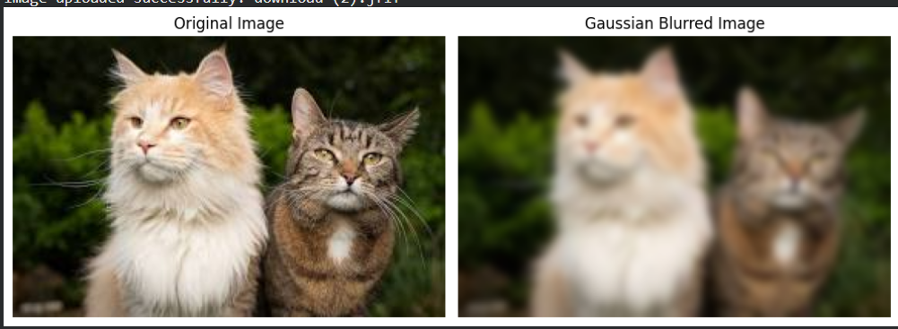

Result
The input image was successfully read using Python and Gaussian Blur was applied using OpenCV. The blurred image showed reduced noise and fine details compared with the original image.

